**Universidad de las Fuerzas Armadas–ESPE**

Departamento de Ciencias de la Computación, Carrera software.

Asignatura: POO, Quito-Ecuador, Fecha de entrega: 14-06-2021

**Nombre:** Nicolás Suquillo

**NRC:** 3682

**Primitive data Python and Java**

What types of data does Python bring with it?

The basic Python data types are Boolean, numeric (integer, floating point, and complex), and character strings.

**Numeric types**

Python defines three basic numeric data types: integers, floating point numbers (it would simulate the set of real numbers, but we will see that this is not the case at all), and complex numbers.

**Integer numbers**

The type of the integers is int. This type of data comprises the set of all integers, but since that set is infinite, in Python the set is really limited by the capacity of available memory. There is no representation limit imposed by language.

**Representation of floating point numbers**

In order to represent as many of the real numbers as possible within the memory limitations (32-bit and 64-bit word sizes), the scientific notation for representing real numbers was adapted to the binary system (which is the system used in programming to represent data and instructions).

In this scientific notation, numbers are represented as follows:

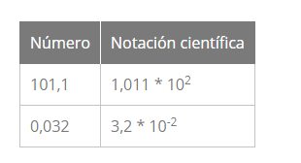

Floating point numbers are represented in computer hardware as base 2 (binary) fractions. And the problem is that most decimal fractions cannot be represented exactly as binary fractions because they have infinite decimal numbers. One consequence is that, in general, the decimal floating-point numbers you use in your applications are an approximation of the binary floating-point numbers actually stored in the machine.

**Boolean type**

In Python the class that represents Boolean values is bool. This class can only be instantiated with two values/objects: True to represent true and False to represent false.

**Character string type**

Another basic type of Python, and essential, are the sequences or character strings. This type is known as string although its true class is str.

Formally, a string is an immutable sequence of characters in Unicode format.

**Python primitive data:**

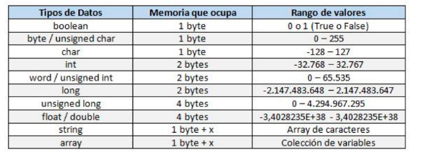

**Java**

In Java there are eight types of primitive data that can be classified into:

Integer numbers (byte, short, int, long).

Real numbers (float, double).

Character (char).

Boolean or logical (boolean).

Of all of them, except for the boolean type that can only be true or false, the following table shows their possible minimum and maximum values:

